**Maproulette Instructions**

**(India Health Facilities)**

**Description:**

The challenge is to improve the health care information of Telangana which can be beneficial for the people in need. In order to do so we need to reposition the coordinate with their actual position (If they are not at the actual position) with the help of local knowledge and add the Additional Tags from the MR Properties to the amenity.

We are using Maproulette and Josm in order to add or modify hospital and all other sorts of health facilities records in OSM. The workflow we are following has been described below-

**Instructions:**

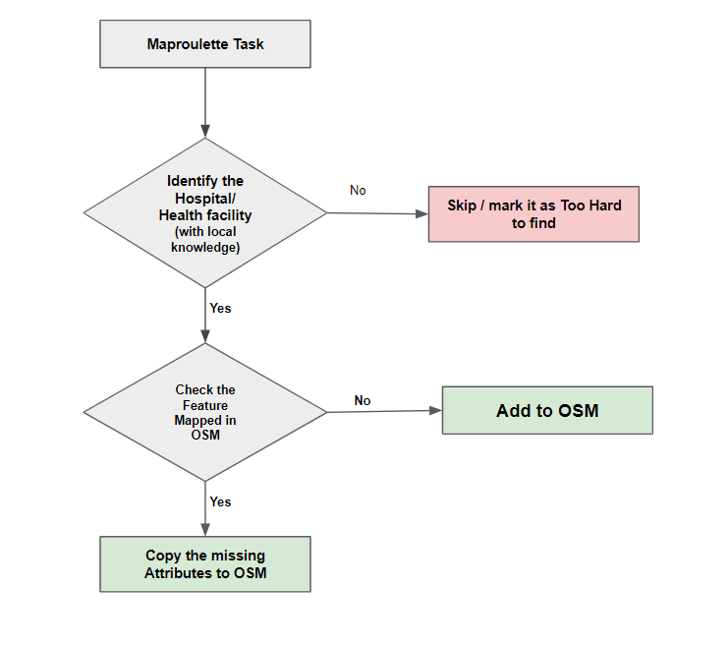

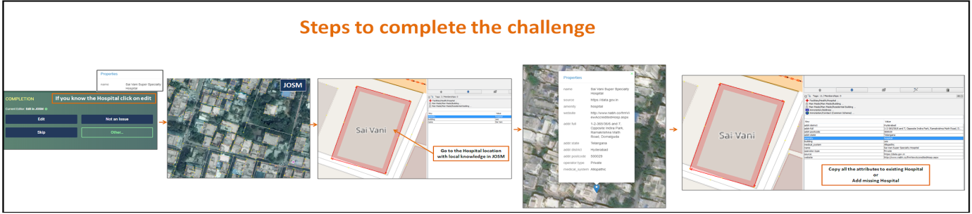

**Step 1: Identify the Facility**

Check for the Hospital/Health Center Name and if you know the Hospital/Health Center then Click on “Edit” if not "Skip" and go for the next task and go to the actual location of the Hospital/Health Center.

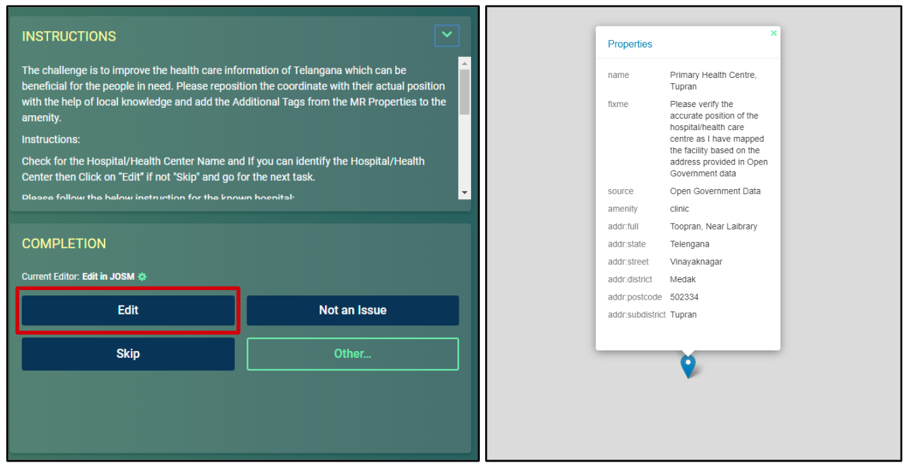

**Step 2: Check for the Existing data**

If the Hospital/Health Center feature is already mapped in OSM, add the missing attributes to existing feature from the MR Task Properties.

If not add a new node on the Hospital/Health Center location and add all the Tags from the MR Task Properties.

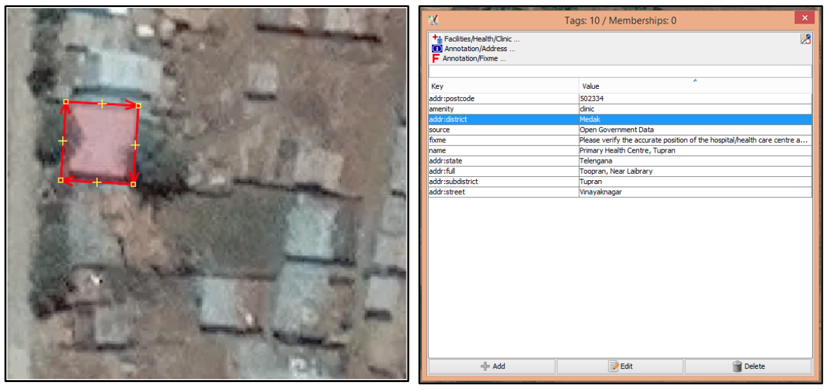

**Note:**

* If building is missing you can add a building feature.
* If the facility is permanently closed mark it as Too Hard.
* Upload the changes with preset Changeset Comment and source.

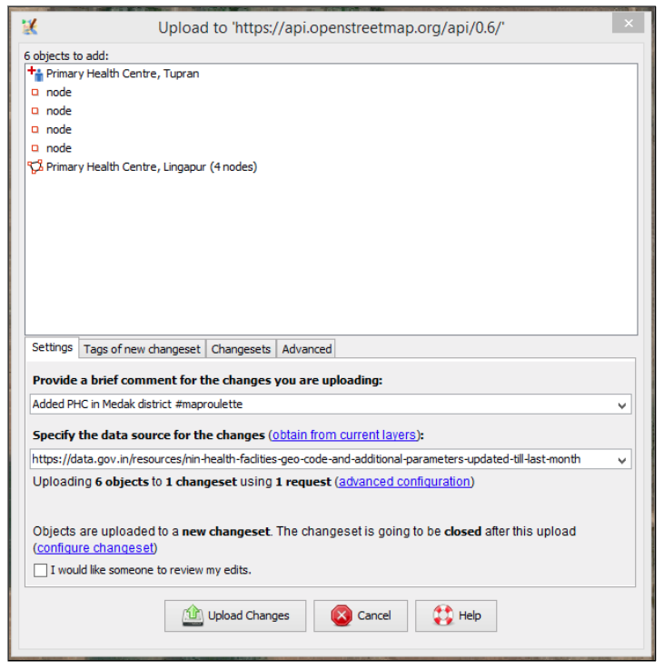

**Maproulette Task Action:**

Mark the task according to action taken.

* **Fixed –** If you add / modified the respected tasks features in OSM
* **Already Fixed –** If the feature is already existing with all tags in OSM
* **Too hard / Can’t see-** If the facility is permanently closed facilities
* **Skip**- If the facility is unknown

